21.63: a) 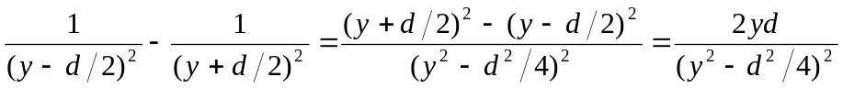
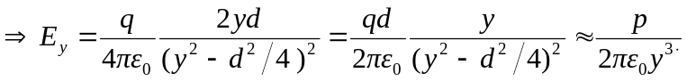
b) This also gives the correct expression for 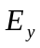since appears in the full expression’s denominator squared, so the signs carry through correctly.

